Real-time AI-based Smart Hearing Protection Prototype for Enhancing Safety Signal Audibility in Work Zones
Thinh Nguyen, S.M.ASCE; Tin Duong; Tuyen Le, A.M.ASCE and Chau Le, A.M.ASCE;

Appendix A
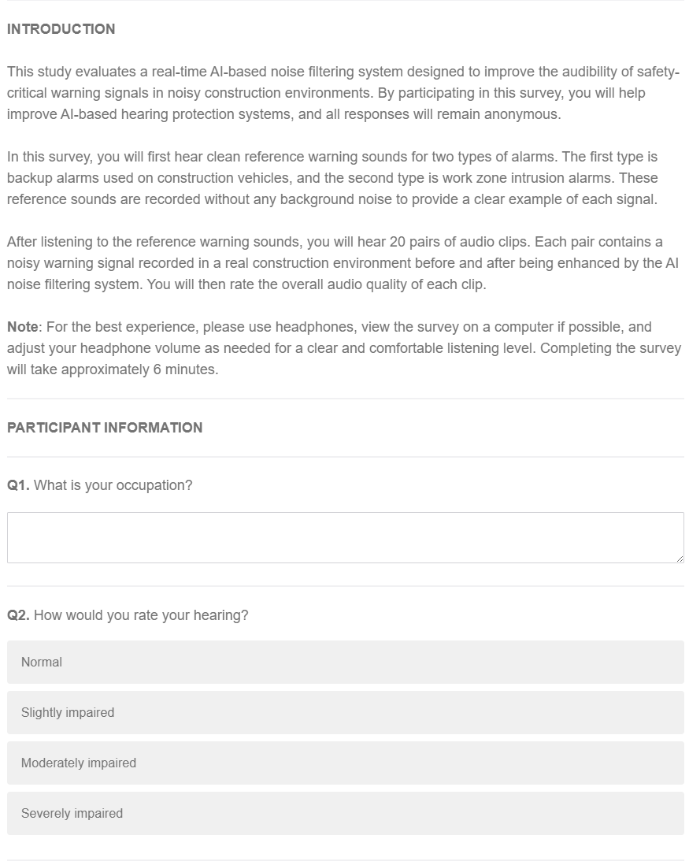
Figure A-1 Survey introduction and participant information section

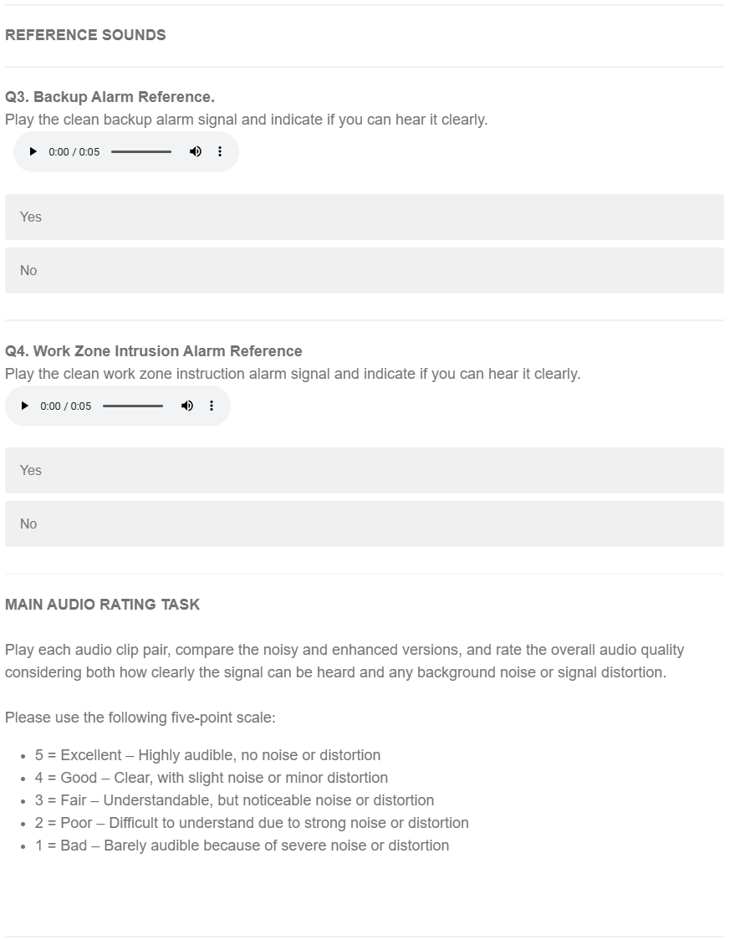
Figure A-2 Reference sound playback and instructions for the main audio rating task
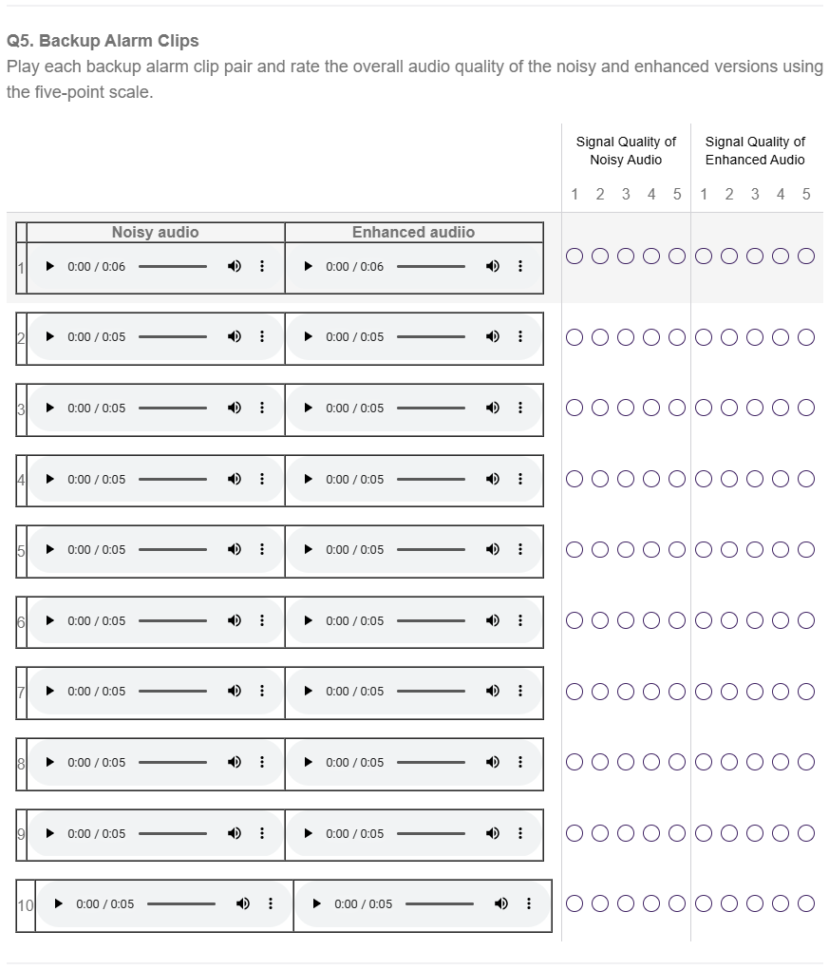
Figure A-3 Backup alarm audio pairs and overall quality rating for noisy and enhanced signals.
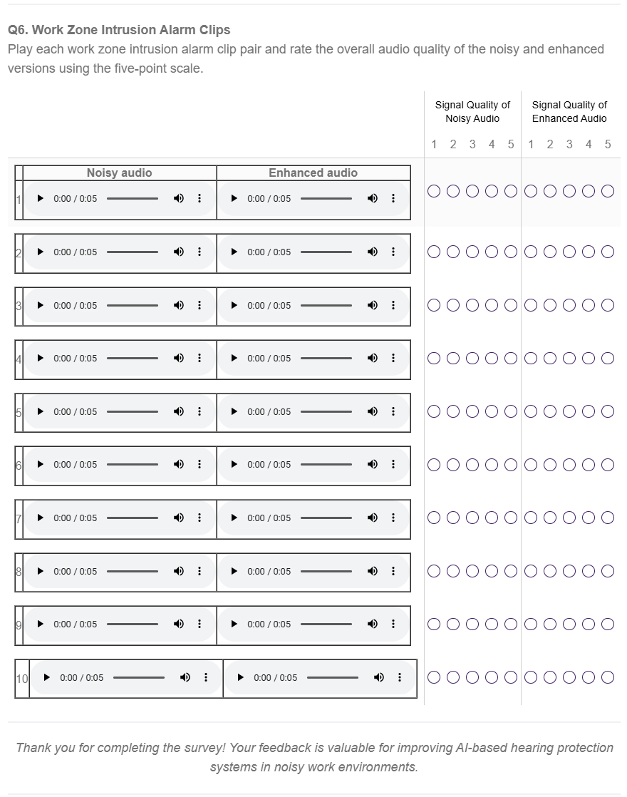
Figure A-4 Work zone intrusion audio pairs and overall quality rating for noisy and enhanced signals

Ph.D. Student, Glenn Department of Civil Engineering, Clemson University, Clemson, SC 29634, USA, Email: thinh@clemson.edu
Ph.D. Student, Glenn Department of Civil Engineering, Clemson University, Clemson, SC 29634, USA, Email: tind@clemson.edu
Associate Professor, Glenn Department of Civil Engineering, Clemson University, Clemson, SC 29634, USA (corresponding author), ORCID: https://orcid.org/0000-0002-8606-9214. Email: tuyenl@clemson.edu
Assistant Professor, Department of Engineering Technology and Construction Management, The University of North Carolina at Charlotte, Charlotte, NC 28223, USA, ORCID: https://orcid.org/0000-0002-2582-2671. Email: chau.le@charlotte.edu

